**CHAPTER 7 MAGNETIC CIRCUITS**

**EXERCISE 33, Page 83**

**1.** What is the flux density in a magnetic field of cross-sectional area 20  having a flux of 3 mWb?

**Flux density, B** =  = **1.5 T**

**2.** Determine the total flux emerging from a magnetic pole face having dimensions 5 cm by 6 cm, if the flux

density is 0.9 T.

 from which, **flux**,  = **2.7 mWb**

**3.** The maximum working flux density of a lifting electromagnet is 1.9 T and the effective area of a pole face

is circular in cross-section. If the total magnetic flux produced is 611 mWb determine the radius of the

pole face.

 from which,  and **radius, r** =  = 0.32 m or **32 cm**

**4.** A current of 5 A is passed through a 1000-turn coil wound on a circular magnetic circuit of radius

120 mm. Calculate (a) the magnetomotive force, and (b) the magnetic field strength.

(a) **Magnetomotive force,** **m.m.f.** = NI = (1000)(5) = **5000 A**

(b) Length of magnetic field, l = 2πr = 2π(0.120) m

Hence, **magnetic field strength,** **H** =  = **6631 A/m**

**5.** An electromagnet of square cross-section produces a flux density of 0.45 T. If the magnetic flux is 720 μWb

find the dimensions of the electromagnet cross-section.

Flux density, B =  from which,

cross-sectional area, A = 

If each side of the square cross-section is x, then = 16 and x = = 4

Hence, **the dimensions of the electromagnet cross-section is 4 cm by 4 cm**

**6.** Find the magnetic field strength applied to a magnetic circuit of mean length 50 cm when a coil of 400 turns

is applied to it carrying a current of 1.2 A

**Magnetic field strength,** **H** =  = **960 A/m**

**7.** A solenoid 20 cm long is wound with 500 turns of wire. Find the current required to establish a

magnetizing force of 2500 A/m inside the solenoid.

Magnetic field strength, H = 

from which, current, I = = **1 A**

**8.** A magnetic field strength of 5000 A/m is applied to a circular magnetic circuit of mean diameter 250 mm.

If the coil has 500 turns find the current in the coil.

Length of magnetic field, l = πd = π(0.25) m

 from which, **current, I** =  = **7.85 A**

**EXERCISE 34, Page 85**

**1.** Find the magnetic field strength and the magnetomotive force needed to produce a flux density

of 0.33 T in an air-gap of length 15 mm.

 from which, **magnetic field strength, H** =  = **262600 A/m**

**Magnetomotive force, m.m.f.** = H × l = 262600  = **3939 A**

**2.** An air-gap between two pole pieces is 20 mm in length and the area of the flux path across the

gap is 5. If the flux required in the air-gap is 0.75 mWb find the m.m.f. necessary.

 for air, from which, H = 

and **m.m.f.** = H × l =  = **23870 A**

**3.** (a)Determine the flux density produced in an air-cored solenoid due to a uniform magnetic field

strength of 8000 A/m. (b) Iron having a relative permeability of 150 at 8000 A/m is inserted into

the solenoid of part (a). Find the flux density now in the solenoid.

(a)  for air, from which, **flux density, B** =  = **10.05 mT**

(b)  from which, **flux density, B** =  = **1.508 T**

**4.** Find the relative permeability of a material if the absolute permeability is 4.084 x 10-4 H/m.

Absolute permeability, μ =  from which, **relative permeability**,  = **325**

**5.** Find the relative permeability of a piece of silicon iron if a flux density of 1.3 T is produced by a

magnetic field strength of 700 A/m.

 from which, **relative permeability, ** =  = **1478**

**6.** A steel ring of mean diameter 120 mm is uniformly wound with 1500 turns of wire. When a current of

0.30 A is passed through the coil a flux density of 1.5 T is set up in the steel. Find the relative permeability

of the steel under these conditions.

Length of magnetic field, l =

Magnetic field strength, H = A/m

 from which, **relative permeability, ** =  = **1000**

**7.** A uniform ring of cast steel has a cross-sectional area of 5 and a mean circumference of

15 cm. Find the current required in a coil of 1200 turns wound on the ring to produce a flux of

0.8 mWb. (Use the magnetisation curve for cast steel shown on page 83 of textbook)

Length of magnetic field, l =, c.s.a., A = , flux, 

Flux density, B =  = 1.6 T

From the graph of cast steel on page 83, when B = 1.6 T, H = 4800 A/m

Magnetomotive force, m.m.f. =

from which, **current, I** =  = **0.60 A**

**8.** (a) A uniform mild steel ring has a diameter of 50 mm and a cross-sectional area of 1. Determine the

m.m.f. necessary to produce a flux of 50 μWb in the ring. (Use the B-H curve for mild steel shown on

page 83).

(b) If a coil of 440 turns is wound uniformly around the ring in part (a) what current would be

required to produce the flux?

(a) Length of magnetic field, l = , c.s.a., A = , flux, 

Flux density, B =  = 0.5 T

From the graph of mild steel on page 83, when B = 0.5 T, H = 700 A/m

Magnetomotive force, **m.m.f.** = = **110 A**

(b) m.m.f. = N I from which, **current, I** =  = **0.25 A**

**9.** From the magnetisation curve for mild steel shown on page 83, derive the curve of relative permeability

against magnetic field strength. From your graph determine (a) the value of μr when the magnetic field

strength is 1200 A/m, and (b) the value of the magnetic field strength when μr is 500

B = μ0 μr H hence μr =  =  = 

A number of co-ordinates are selected from the B-H curve and μr is calculated for each as shown in the following table.

|  |  |
| --- | --- |
| B (T) | 0.10 0.35 0.55 0.72 1.03 1.24 1.37 |
| H (A/m) | 250 500 750 1000 1500 2000 2500 |
|  | 318 577 583 573 541 493 436 |

μr is plotted against H as shown below.

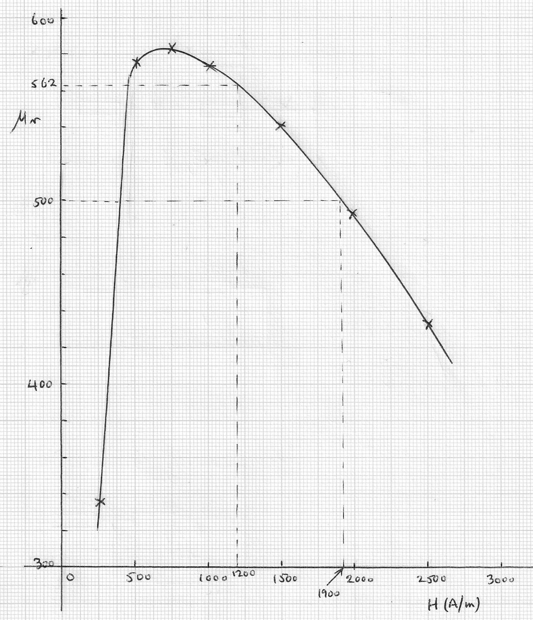

(a) From the graph, the value of μr when the magnetic field strength is 1200 A/m is **around 560 - 565**

(b) The value of the magnetic field strength when μr is 500 is **around 400 A/m** **or 1900 A/m**

**EXERCISE 35, Page 86**

**1.** Part of a magnetic circuit is made from steel of length 120 mm, cross-sectional area 15 and

relative permeability 800. Calculate (a) the reluctance and (b) the absolute permeability of the

steel.

(a) **Reluctance, S** =  = **79580 /H** or **79580 A/Wb**

(b) **Absolute permeability**,  = **1 mH/m**

**2.** A mild steel closed magnetic circuit has a mean length of 75 mm and a cross-sectional area of

320.2 . A current of 0.40 A flows in a coil wound uniformly around the circuit and the flux

produced is 200 μWb. If the relative permeability of the steel at this value of current is 400 find

(a) the reluctance of the material and (b) the number of turns of the coil.

(a) **Reluctance, S** =  = **466000 /H**

(b) S =  from which, **number of turns, N** =  = **233**

**EXERCISE 36, Page 89**

**1.** A magnetic circuit of cross-sectional area 0.4 consists of one part 3 cm long, of material

having a relative permeability 1200, and a second part 2 cm long of material having a relative

permeability 750. With a 100 turn coil carrying 2 A, find the value of flux existing in the circuit.

Reluctance of part 1,  = 497359 /H

Reluctance of part 2,  = 530516 /H

Total reluctance, 

 from which, **flux**,  = **0.195 mWb**

**2.** (a) A cast steel ring has a cross-sectional area of 600 and a radius of 25 mm. Determine the

m.m.f. necessary to establish a flux of 0.8 mWb in the ring. Use the B-H curve for cast steel

shown on page 83. (b) If a radial air gap 1.5 mm wide is cut in the ring of part (a) find the

m.m.f. now necessary to maintain the same flux in the ring.

(a) c.s.a., A = , length of magnetic circuit, l = 2πr = 2π ,

 = 1.33333 T = 1.33 T, correct to 2 decimal places.

From the graph of cast steel on page 83, when B = 1.33 T, H = 1720 A/m

**m.m.f.** = H × l = 1720 × 2π  = **270 A**

(b) For the air gap,  from which, H =  = 1061030 A

m.m.f. = H × l = 1061030 ×  = 1592

**Total m.m.f.** = 270 + 1592 = **1860 A**, correct to 4 significant figures

**3.** A closed magnetic circuit made of silicon iron consists of a 40 mm long path of cross-sectional area 90 mm2

and a 15 mm long path of cross-sectional area 70 mm2. A coil of 50 turns is wound around the 40 mm

length of the circuit and a current of 0.39 A flows. Find the flux density in the 15 mm length path if the

relative permeability of the silicon iron at this value of magnetising force is 3000.

**For the 40 mm long path:**

Reluctance S1 =  =  = 117892.55/H

**For the 15 mm long path:**

Reluctance S2 =  =  = 56841.05/H

Total circuit reluctance S = S1 + S2 = 117892.55 + 56841.05 = 174733.6/H

S =  i.e. Φ =  =  =  = 1.116 × 10-4 Wb

Flux density in the 15 mm path, B =  =  = **1.59 T**

**4.** For the magnetic circuit shown below, find the current I in the coil needed to produce a flux of 0.45 mWb in

the air-gap. The silicon iron magnetic circuit has a uniform cross-sectional area of 3 cm2 and its

magnetisation curve is as shown on page 83 of textbook.

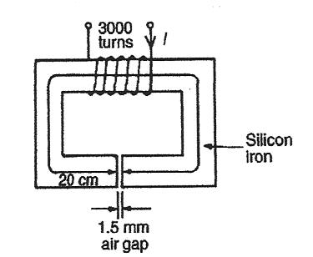

For the silicon iron core, B =  = 1.5 T

From the magnetisation curve (on page 83), H = 3500 A/m

For the air gap,  = μo since  = 1

from which, H = =  = 1193662 A/m

Total m.m.f, m.m.f.T  = m.m.f.ring + m.m.f.gap

= Hring + Hgap

Hrring = 3500 = 700 A

Hgap  = 1193662 = 1790.5 A

m.m.f.T­ = 700 + 1790.5 = 2490.5 A

Since m.m.f. = NI, **current,** **I** = = **0.83 A**

**5.** A ring forming a magnetic circuit is made from two materials; one part is mild steel of mean

length 25 cm and cross-sectional area 4, and the remainder is cast iron of mean length 20 cm

and cross-sectional area 7.5. Use a tabular approach to determine the total m.m.f. required to

cause a flux of 0.30 mWb in the magnetic circuit. Find also the total reluctance of the circuit. Use

the magnetization curves shown on page 83.

Mild steel: l = 0.25 m, c.s.a., A = 

Cast iron: l = 0.20 m, c.s.a., A = 

|  |  |  |  |  |  |  |
| --- | --- | --- | --- | --- | --- | --- |
| **Part of circuit** | **Φ (Wb)** | **A ()** | **B (T)** | **H (A/m)**  **(from graph)** | **l (m)** | **mmf = H × l** |
| Mild steel | 0.30 |  | 0.75 | 1000 | 0.25 | 250 |
| Cast iron | 0.30 |  | 0.40 | 1500 | 0.20 | 300 |

**Total: 550 A**

**Total reluctance, S** =  = 

**6.** The diagram below shows the magnetic circuit of a relay. When each of the air gaps are 1.5 mm

wide find the m.m.f. required to produce a flux density of 0.75 T in the air gaps. Use the B-H

curves shown on page 83.

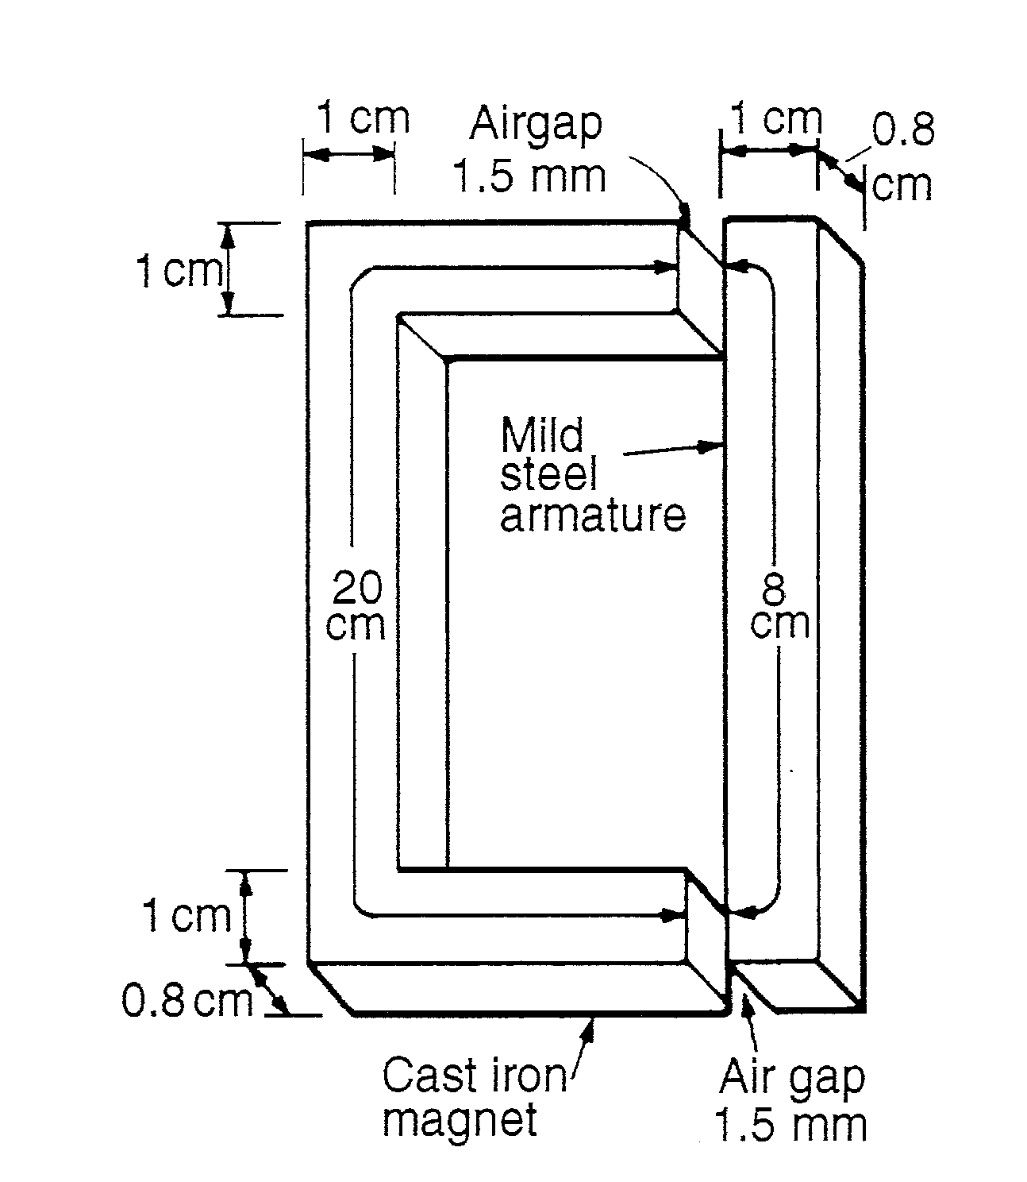

|  |  |  |  |  |  |
| --- | --- | --- | --- | --- | --- |
| **Part of circuit** | **A ()** | **B (T)** | **H (A/m)**  **(from graph)** | **l (m)** | **mmf = H × l** |
| Cast iron |  | 0.75 | 5500 | 0.20 | 1100 |
| Mild steel |  | 0.75 | 1000 | 0.08 | 80 |
| Air |  | 0.75 |  |  | 1790 |

**Total: 2970 A**